Final Project ER Diagram

Craig Justin Vinoya Balibalos, Jonathan Dimitriu, Dinal Patel

Sleiman Rabah

Our idea: Nobel Prize Laureates

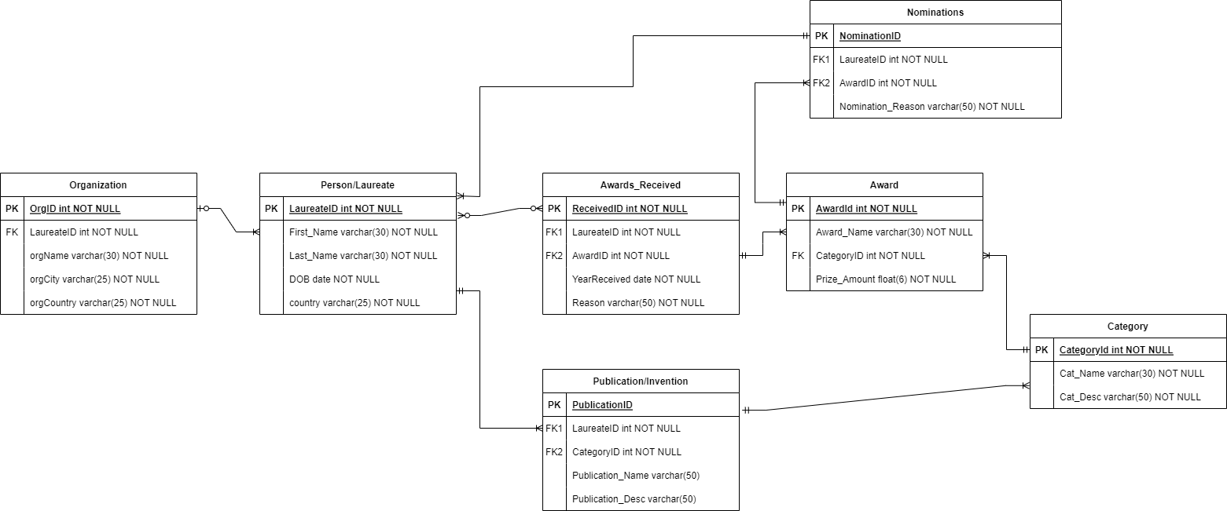

Organization to Person/Laureate: 1 organization can have many laureates. 0 or 1 laureate can belong to an organization.

Person/Laureate to Nomination: 1 laureate has one mandatory nomination. 1 nomination can belong to many laureates.

Person/Laureate to Awards Received: 1 Person can receive 0 or many awards. 0 or many awards can belong to 1 person.

Person/Laureate to Publication/Invention: 1 Person can have 1 or many Publication. 1 Publication can have only 1 Laureate.

Publication/Invention to Category: 1 Publication can belong to only 1 category. 1 Category can have many Publications.

Category to Award: 1 category can have only 1 award. 1 award can belong to only 1 Category.